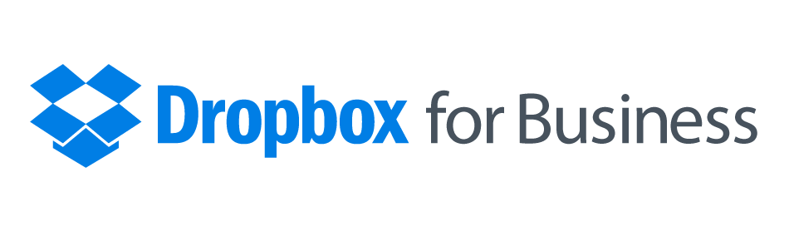

The Dropbox your team loves,
the control your business needs
Get the solution 300 million users trust to store, sync, and share files securely, along with the admin tools IT needs to protect your business.
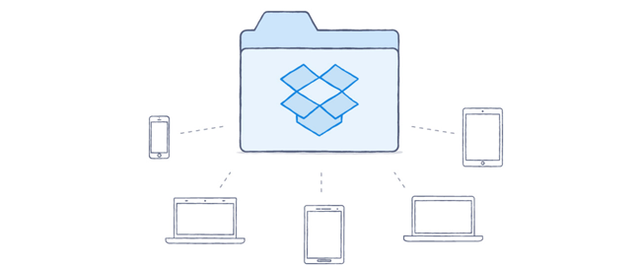

Any app. Any device. Anywhere
Dropbox for Business works with all the apps your team already uses to be productive — everything from Word and Excel to Photoshop and Acrobat. Plus support for Windows, Android, iOS, Mac, and Linux mean no one's left out in the cold. Just create a folder, share it, and start collaborating instantly.
Any app, any format
Desktop, mobile, web
Simplified sharing
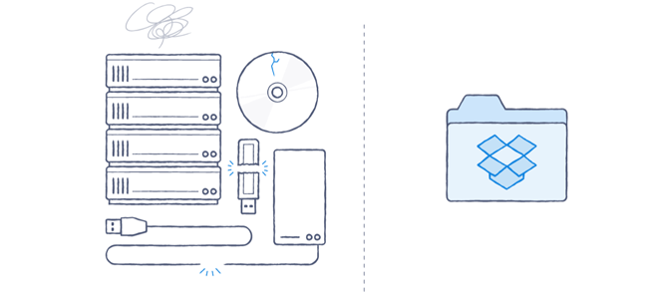

Less training, more productivity
So long, clunky FTP servers, on-premises storage, and email attachments. With an intuitive interface and best-in-class performance, getting your team on one system is simple. Self-service features like unlimited deletion recovery and device unlinking let team members handle common tasks without bothering IT. All of which means less time training and troubleshooting, and more time being productive.
Reduced strain on IT
Unlimited file recovery
Device management

Keep tabs on sharing and control access
When employees use a jumble of different solutions, maintaining control becomes difficult. Give them the one product that 300 million users love, and keep company information inside your company. Dropbox for Business gives IT admins comprehensive audit logs to track what's being shared and who's sharing it. Easy-to-use controls restrict access, while remote wipe secures data if a device is lost. Users can also connect a personal and a work Dropbox so vacation photos stay separate from sales presentations, but both remain right at their fingertips.
Complete audit log
Remote wipe
Sharing controls
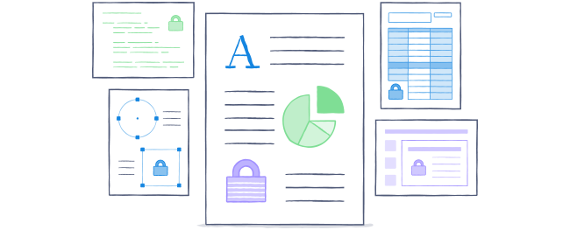

Secure company information
Safeguarding your team's data is our top priority. Dropbox for Business uses strong cipher encryption for file data in transit and at rest, as well as file segmentation and hashing to anonymize files. We also undergo regular ISO 27001 and Service Organization Control (SOC) audits, and make the SOC 1, 2, and 3 reports available for review. Teams can secure accounts even further with authentication features like single sign-on (SSO) support and two-step verification.
Strong encryption
Single sign-on
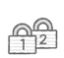Two-step verification
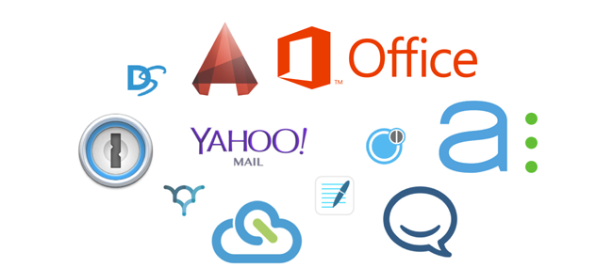

300,000 apps to extend Dropbox
No platform lets you access your data in more ways than Dropbox. Over 300,000 third-party apps connect to Dropbox for productivity, analytics, communications, and more. Edit documents with Microsoft Office, share with collaborators in Cisco WebEx Meetings, and get contracts approved with DocuSign. You can also streamline management and bolster security with IT solutions from IBM, Dell, Splunk, and other partners. Check out the third-party apps that connect to Dropbox for Business.
Microsoft Office
Asana
WebEx
DocuSign
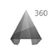AutoCAD 360

Get your team in sync

